**A Secondary School Coding Project**

**Version 1.2 18/11/15**

**to Build, Programme and Test an Autonomous Mars Rover**

**Requirement**

The new English and Scottish school curricula require pupils to learn about computer programming.

Programming games on a computer screen is a common solution to this requirement, but pupils with an interest in STEM (Science, Technology, Engineering and Maths) find it particularly interesting and relevant if their programming has an exciting and practical real-time outcome and experience. The object of their programming must therefore physically exist, move and do something.

To be viable as a schools educational tool the practical requirements are:

1. Educational Value
2. Low Cost
3. Teacher support resources for hardware and software
4. A practical vehicle to demonstrate and understand real time coding, control algorithms and mathematical concepts.
5. Computer software programme written in a popular language with full open access
6. A versatile and powerful microprocessor
7. Capable of performing basic autonomous functions with minimal electronic computing and coding knowledge.
8. Sensors and actuators to interface and calibrate
9. Ease of Installation
10. Large platform for mounting a number of sensors and actuators for experimentation
11. Modular construction
12. Maximum pupil involvement with the ability to share the hardware test vehicle.
13. Allow pupils to develop code off line and visually see the simulated results on a computer monitor before practically testing the hardware.
14. Provide the growth potential to stretch and challenge pupils as they use and modify the code and add extra and different sensors etc. to improve the accuracy and capability
15. A radio control function to provide a safe GO/STOP command
16. Sporty, but safe performance

**Solution**

A ‘Mars Rover’ autonomous vehicle fits this basic requirement, includes a space exploration dimension and allows great scope for coding experimentation, improvements and expansion by the addition of other STEM modules such as additional sensors, actuators, soil sampling and chemical analysis.

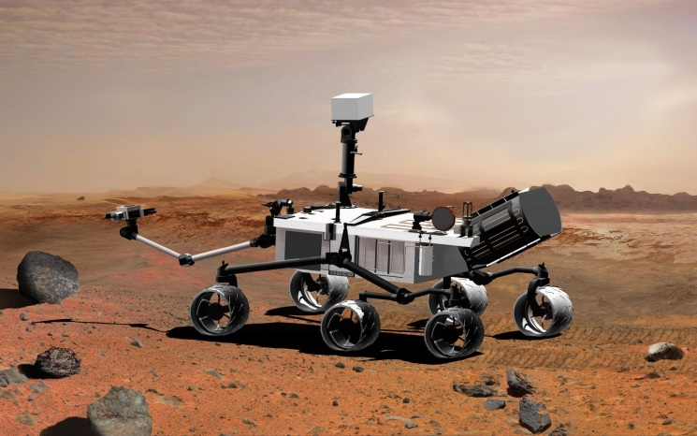

**NASA ‘Curiosity’ Mars Rover**

Secondary school pupils and their teachers who have participated in the Rampaging Chariots STEM Project have suggested that we extend this existing popular project to provide a versatile Mars Rover for secondary school pupils to learn coding with a practical and exciting outcome.

**Modifying the Basic Rampaging Chariot Chassis for Autonomous Operation as a**

**‘Mars Rover’**

A ‘Rampaging Chariot’ vehicle chassis is a highly cost effective way of providing a ‘Mars Rover’ autonomous vehicle as it uses an existing proven vehicle that is already in over 200 secondary schools throughout the United Kingdom.

This basic radio controlled sporting robot, that is constructed from a comprehensive kit of parts, would be enhanced by the addition of an ‘Autonomous Upgrade Kit’ to provide the ‘Mars Rover’ autonomous functions to satisfy the educational coding requirements..

**The Rampaging Chariot Sporting Robot**

**STEM** **Project**

Rampaging Chariots is an exciting robotic project sponsored by Selex-ES and the IEE, aimed at interesting young people in the fun of technology and engineering by constructing radio controlled sporting robots from a comprehensive kit to compete in a National competition.

It is a proven and highly popular STEM project that been going for over 10 years and is well embedded in secondary school Young Engineers Clubs and youth organisations. It covers several diverse disciplines and is highly acclaimed by teachers. The project goal is to enter the annual robotic games hosted by Selex ES at their Edinburgh, Luton or Basildon sites, and compete in four events: Assault Course, Sumo, Tug-of-War and Two-a -Side Football.

This four wheeled sporting robot is relatively large and is powered by two powerful 18v electric drills.

A radio control system is included in the kit. (Appendix A)

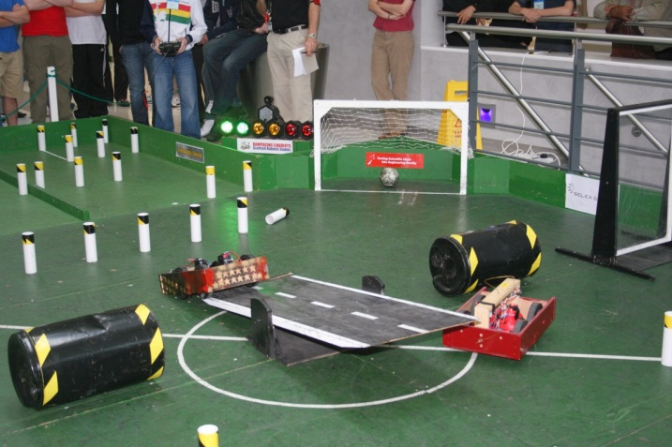

**Rampaging Chariots on the Assault Course at the Robotic Games**

**Requirements For the Rampaging Chariots Autonomous Upgrade Kit to Produce a**

**‘Mars Rover’**

1. A basic kit of parts to be provided as a free/sponsored upgrade to a standard Rampaging Chariot sporting robot.
2. Aimed at Secondary school pupils who have already built and competed with a standard Rampaging Chariot in the Scottish or English Robotic Games hosted by Selex-ES.
3. A simple interface to allow the sensors to be connected physically and electrically. This should also provide the essential protection needed to prevent damaging 5v signals reaching the R-Pi.
4. Example Code Modules that allow the autonomous vehicle to be up and running quickly and contain basic functions that can be modified by changing the values of defined parameters.
5. Modules should be capable of alteration to improve accuracy, capability and additional functions.
6. Modules should be fully described and documented in ways a pupil of age 12 to 18 can understand and learn how to alter various parameters for scaling or experiments.
7. Full circuit diagrams of each interface should be provided together with the relevant parts (simplified) of technical data sheets.
8. Allow the autonomous system to be detached to allow pupils to develop code off line and visually see the simulated results on a computer monitor.
9. A radio control ‘Remote Kill’ function to provide a safe GO/STOP command
10. A switch to allow the Rampaging Chariot to be switched between Standard Radio Control and Autonomous operation.
11. All abbreviations and concepts should be expanded and explained in side notes or an appendix.
12. Video tutorials to be provided
13. Data Logging or Telemetry capability

Sensors

1. Low Cost (Total: target £25 plus R-Pi)
2. Educational Value
3. Accuracy
4. Ease of Installation

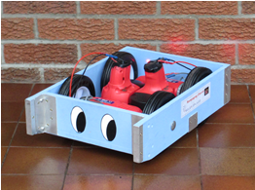

**Standard Rampaging Chariot**

The basic standard Rampaging Chariot can be modified easily for autonomous operation and provides an ideal platform for teaching practical computer programming skills and experiencing the result of real time experimenting with algorithms and sensors. It shows pupils that practical interfacing with the real world is a challenge because the environment and real sensors do not allow perfect performance like programming an icon on a computer screen.

The Rampaging Chariot chassis can be fitted with a flat top of 40cm x 30cm size which is an excellent platform to mount a programmable microprocessor such as Raspberry Pi or Arduino, together with fixed and scanning sensors of all descriptions. A digital interface to the standard chassis motor control Printed Circuit Board (PCB) is already incorporated in all recent Rampaging Chariots.

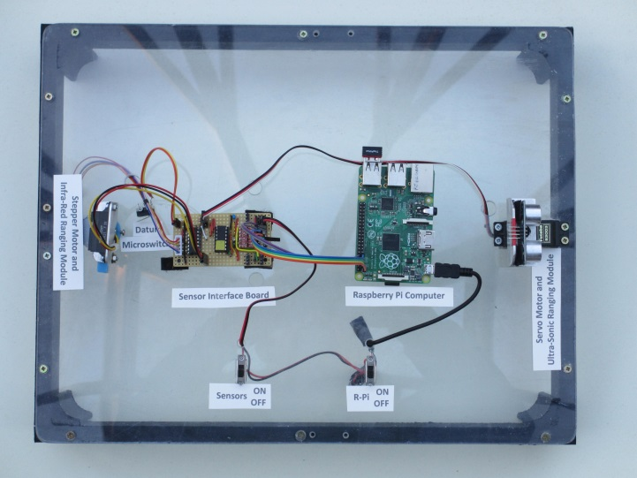

**Additional Lid For Autonomous Operation**

The autonomous modification involves the design, procurement, and installation of a number of sensors together with the design and coding of a microprocessor. This is followed by integration and testing of the sensors, interface, microprocessor and software code.

The ‘Mars Rover’ autonomous modification gives programming a practical real-time outcome and experience and allows the project to be extended for senior secondary pupils and college/university students. The aim is to achieve an autonomous modification that will undertake tasks such as navigating around the assault course at the annual Rampaging Chariot Robotic Games. More advanced challenges might include Sumo and Two-a-Side Football. Actuators such as a robot arm and soil sample analysis.

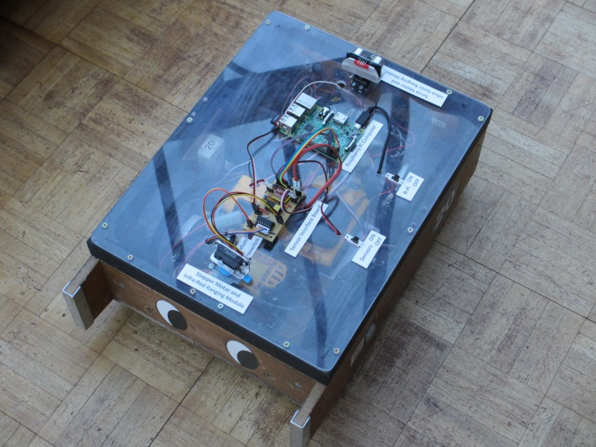

**Autonomous Prototype**

**Choice of Microprocessor and Computing Language**

The two most popular microprocessors currently used by schools are the Raspberry Pi and the Arduino.  We are concentrating initially on the Raspberry Pi as this is a complete computer and it has extensive publicity and web resources.

1. Low Cost, (R-Pi £27, SD Card £5.4, Power supply £4.5, (Optional Wi-Fi or Bluetooth Dongle £10). Total=£37 excluding dongle)
2. Uses readily available hardware resources in schools such as HDMI monitor
3. It can be programmed using Python which is arguably the most useful language for those likely to go to University.
4. Has considerable support on-line and is already used to teach coding.
5. Has the interfaces, speed and resources to do the main control and simulation tasks

The coding of autonomous algorithms on a microprocessor such as a Raspberry Pi is particularly challenging and we aim to produce and provide documented modules of code for inclusion on our web site to assist students to get a basic system up and running.

The Rampaging Chariots Guild will also develop and run a web forum that would assist students and allow an interchange of ideas and solutions to problems.

**Demonstration Modules of Code**

**Concept**

Provide a distributed processing architecture where students have full control over the main navigation code residing in the Raspberry Pi and use a simple STANDARD serial interface (I2C) to address all the sensors.

The autonomous software provided for the Raspberry Pi is to be divided into a number of documented modules over which students will have full modification capability. Read only copies of the default version of each module will be provided for substitution if students get into difficulties when programming.

Each sensor is to have a standard interface which outputs raw data to allow students the maximum flexibility to access and modify the basic calibration data provided in the Raspberry Pi autonomous control modules.

The code modules provided are:

Navigation Module,

Sensors Module

Visualisation Module.

Analysis Module

Example Code Modules contain basic functions that can be modified by changing the values of defined parameters. These modules contain code that can be added to and altered to allow additional functions.

All the code blocks will be open source and published in a resource section of our website: [www.rampagingchariots.org.uk](http://www.rampagingchariots.org.uk) Video tutorials will also be provided.

**Basic Sensors**

A simple set of cheap sensors is to be provided with the Autonomous upgrade kit. These are to be sufficient to allow students to get the upgrade working quickly and easily. Additional sensors can be purchased by students as required.

The Autonomous Upgrade Kit contains

Sensors, Microprocessor and an Interface module.

1. Two magnetic Odometers to sense the distance travelled by each drive wheel and allow robot heading to be determined
2. Infra-Red distance measurer
3. Ultra-Sonic Distance measurer
4. Stepper Motor for Scanning
5. Servo Motor for Scanning

Provision to allow pupils to interface other sensors and actuators such as:

Laser Ranging

Compass

Camera

Servo

Robot Arm

GPS,

Gyros

Accelerometers

Data Logger

Telemetry

Smart Phone

**Autonomous Competition**

To enable senior pupils and students to participate, we intend to have an event for Autonomous Rampaging Chariots. We challenge senior school and university students to modify a standard Rampaging Chariot to undertake any of the Sumo, Assault Course, Tug-of-War or Football events with no human intervention.

***Autonomous Rampaging Chariots Rules***

1. An autonomous Rampaging Chariot is defined as one which can accomplish the event without human intervention.
2. The autonomous Rampaging Chariot must conform to the standard definition and rules published on the Rampaging Chariot web site and may be fitted with an alternative PIC issued by the Rampaging Chariot Guild that contains a dedicated serial interface and remote kill function.
3. All navigation, calculation and control functions must be undertaken on board the robot.
4. No additions or modifications to the standard arena or obstacles are allowed.
5. The autonomous robot must be able to operate inside a building.
6. Sensors on board the robot may be used to receive the earth’s magnet field, but off-board beacons or cameras may not be used.
7. The only transmissions or responses to or from the robot that are allowed are:

a. A dedicated 2-way radio link between the two robot members of a football team.

b. A dedicated 1-way telemetry transmitter and/or video transmitter that is used exclusively for real time monitoring and post event analysis.

c. The remote kill safety function

**Safety**

1. An autonomous Rampaging Chariot must be fitted with a remote kill function that brings all of the robot functions to a halt. This could typically be undertaken by the position of a GO- STOP switch or lever on the standard radio transmitter.
2. Laser sensors must conform with Class I.

***DRAFT 1. 16/7/15***